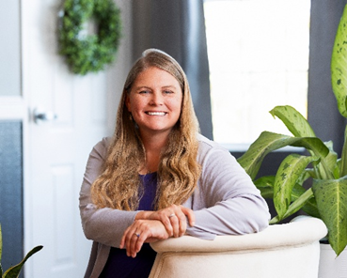
Shawna DuBois – Executive Director, Gabriel’s Retreats
Shawna DuBois is founder, executive director, and board secretary for Gabriel’s Retreat Ministries. She is married to Pete, and they have four children. Shawna is a registered nurse also holding bachelor degrees in psychology and history.
She has worked in both labor and delivery and school nursing. She also holds an Online Catechist Certification from the Paul VI Institute and has assisted in youth ministry and catechesis for over 12 years.
Gabriel’s Retreat Ministries came to her from a place of personal experience after unexpected pregnancies of her own and understanding that there are many psychological, emotional, and spiritual challenges that new motherhood can bring, especially when it was not part of our timing but God’s. She hopes to bring love and support to women going through similar situations and to help them find joy, hope, and peace in their motherhood and time of unexpectedness.

